# MUHAMMAD HASSAM KHAN

**SID: 11141**

**LAB 12 COAL**

## Q1:

CODE:

INCLUDE Irvine32.inc

N=10 ;takes random number

.data

array DWORD N DUP(?) j DWORD ?

k DWORD ?

.code

main PROC call Clrscr

mov j, -10

mov k, 10

mov ESI, OFFSET array mov ECX, N

call FillingAnArray mov j, 10

mov k, 20

mov ESI, OFFSET array mov ECX, N

call FillingAnArray call WaitMsg

exit

main ENDP

FillingAnArray PROC push ecx

push esi l1:

mov eax, j mov ebx, k

dec ebx

sub ebx, eax xchg ebx, eax call RandomRange neg ebx

sub eax, ebx call crlf call WriteInt

mov [esi], eax

add esi, 4 loop l1

pop esi

pop ecx ret

FillingAnArray ENDP END main

## SCREENSHOT:

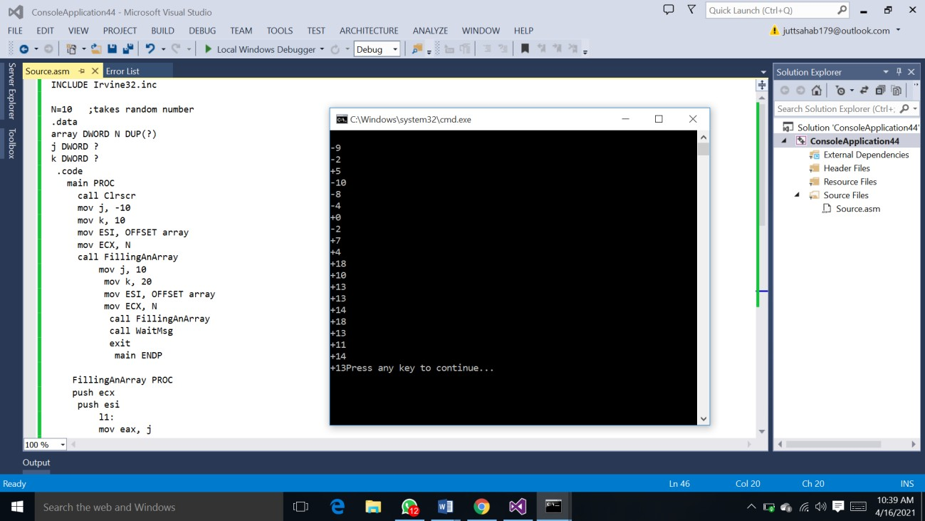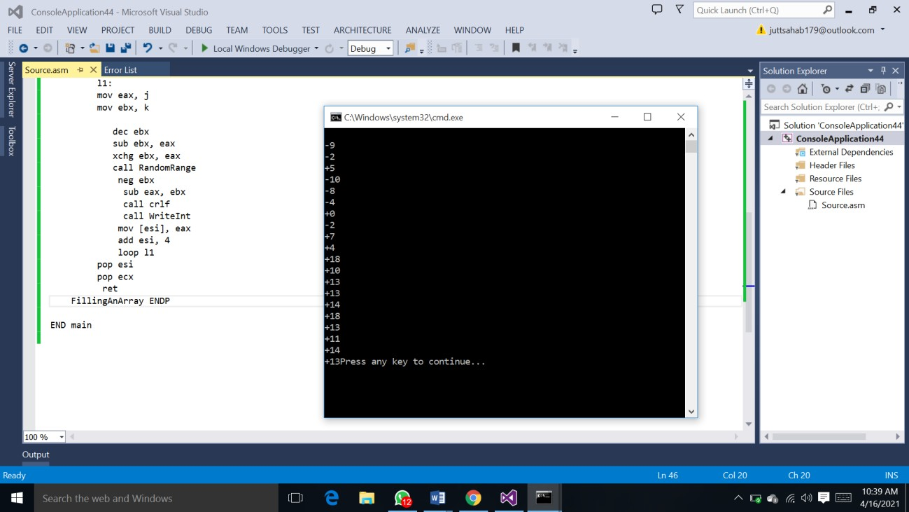

Q2:

CODE:

INCLUDE IRVINE32.inc

.data .code main PROC mov eax,2 push eax mov eax,5 push eax call divof call writeint call crlf divof PROC mov eax,0 mov eax,[esp+4] mov ebx,[esp+8]

sub edx,edx div ebx ret 8 divof ENDP exit main ENDP

END main

SCREENSHOT:

